

Practice closing times throughout December 2022/2023:

We will be closed on 24th, 25th, 26th, 27th and 31st December 2022

And also closed on 1st and 2nd January 2023

Patient Newsletter December 2022

ASK MY GP
730AM – 12.00PM

The practice is continuing to use ask my gp, however when we are extremely busy and the clinicians have reached capacity this can be switched off earlier.
If you require urgent attention and ask my gp has been switched off please call 01476 348 484 and your request will be passed to the Duty Doctor for assessment.

We would like to wish all our patients a very Merry Christmas and very Happy New Year
ST Johns Medical Centre
01476 348 484

GENERAL INFORMATION:

Currently the waiting times for routine x-rays, ultrasounds and MRI’s are standing at 6-8 weeks. They will contact you once an appointment becomes available.

Routine referrals to any specialty field at present there is a wait of around 12-18months.
The aim of PPG is to represent patients views, to support diversity and to work alongside the Practice to improve common understanding.

If you would like to be part of PPG and attend meetings which are held every 3 months at the Practice please enquire at Reception who can provide you with the information you need.

Alternatively you can email the Practice Manager on Nicola.masson@nhs.net
PATIENT PARTICIPATIN GROUP

(ppg)

Staffing:

We are pleased to welcome to the Practice –

Rebecca and Kelly who have joined as Medical Secretaries

Chloe and Hannah who have joined as Medical Receptionists

Dr Aniebonam who has joined as a General Practitioner

Megan D will be joining us in January 2023 as Nurse Lead

And we have said a sad farewell to –

Natasha P – Lead Nurse
Dr Mohsin – Registrar
Dr Zidan – Registrar
Both GP’s will be back with us in August 2023 for their final year.
Tracey C – Medical Secretary
Malgorzata J – Cleaner
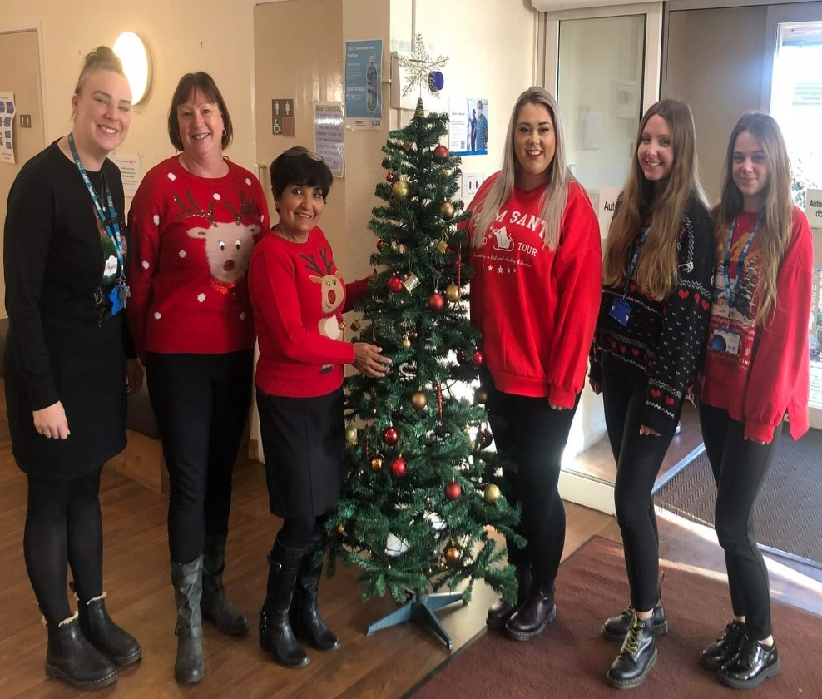

Christmas Jumper Day 2022

This year the Practice raised money for Save the Children UK.
Staff wore their most festive jumpers, participated in activities, and held a cake sale.

